Assignment

Three-Tier Architecture in E-Commerce Application

Introduction
Modern e-commerce platforms must support millions of users, real-time transactions, and continuous service availability. Traditional monolithic architectures struggle to scale efficiently because tightly coupled components limit independent development, deployment, and scaling. To address these challenges, modern systems adopt three-tier architecture combined with microservices deployed on Kubernetes and supported by DevOps practices.

In this architecture, the system is logically separated into three layers: the presentation tier, application tier, and data tier. Each tier performs distinct responsibilities that improve modularity and scalability. The application layer is implemented as containerized microservices, each responsible for a specific business capability such as authentication, product catalog management, shopping cart operations, order processing, and payment handling. Kubernetes orchestrates these microservices, providing container scheduling, networking, service discovery, load balancing, autoscaling, and failure recovery.

DevOps practices complement this architecture by introducing continuous integration, continuous deployment, infrastructure automation, monitoring, and GitOps-based configuration management. These practices ensure rapid software delivery while maintaining system reliability and operational stability.

This document provides an in-depth analysis of how a production-level e-commerce platform operates using Kubernetes and DevOps principles. It examines the system architecture and explains key operational workflows including user authentication, product browsing, add-to-cart operations, checkout processing, payment transactions, and order confirmation. Each scenario demonstrates how the three tiers interact with Kubernetes networking and microservices communication mechanisms.

System Architecture Overview

Three-Tier Architectural Model
The three-tier architecture divides the application into logical layers that separate responsibilities and improve maintainability.
The presentation tier represents the client interface through which users interact with the platform. This layer includes web browsers, mobile applications, and frontend frameworks such as React, Angular, or Vue. It handles rendering user interfaces and sending API requests to backend services.
The application tier contains the core business logic of the platform. Instead of a monolithic application, the business logic is divided into independent microservices. Each microservice implements a specific function such as user authentication, product management, cart processing, order handling, and payment processing.
The data tier stores persistent information required by the system. Databases in this tier manage product data, user accounts, shopping carts, order histories, inventory records, and transaction information.
Separating the system into these tiers enables independent scaling, easier maintenance, and stronger security boundaries.

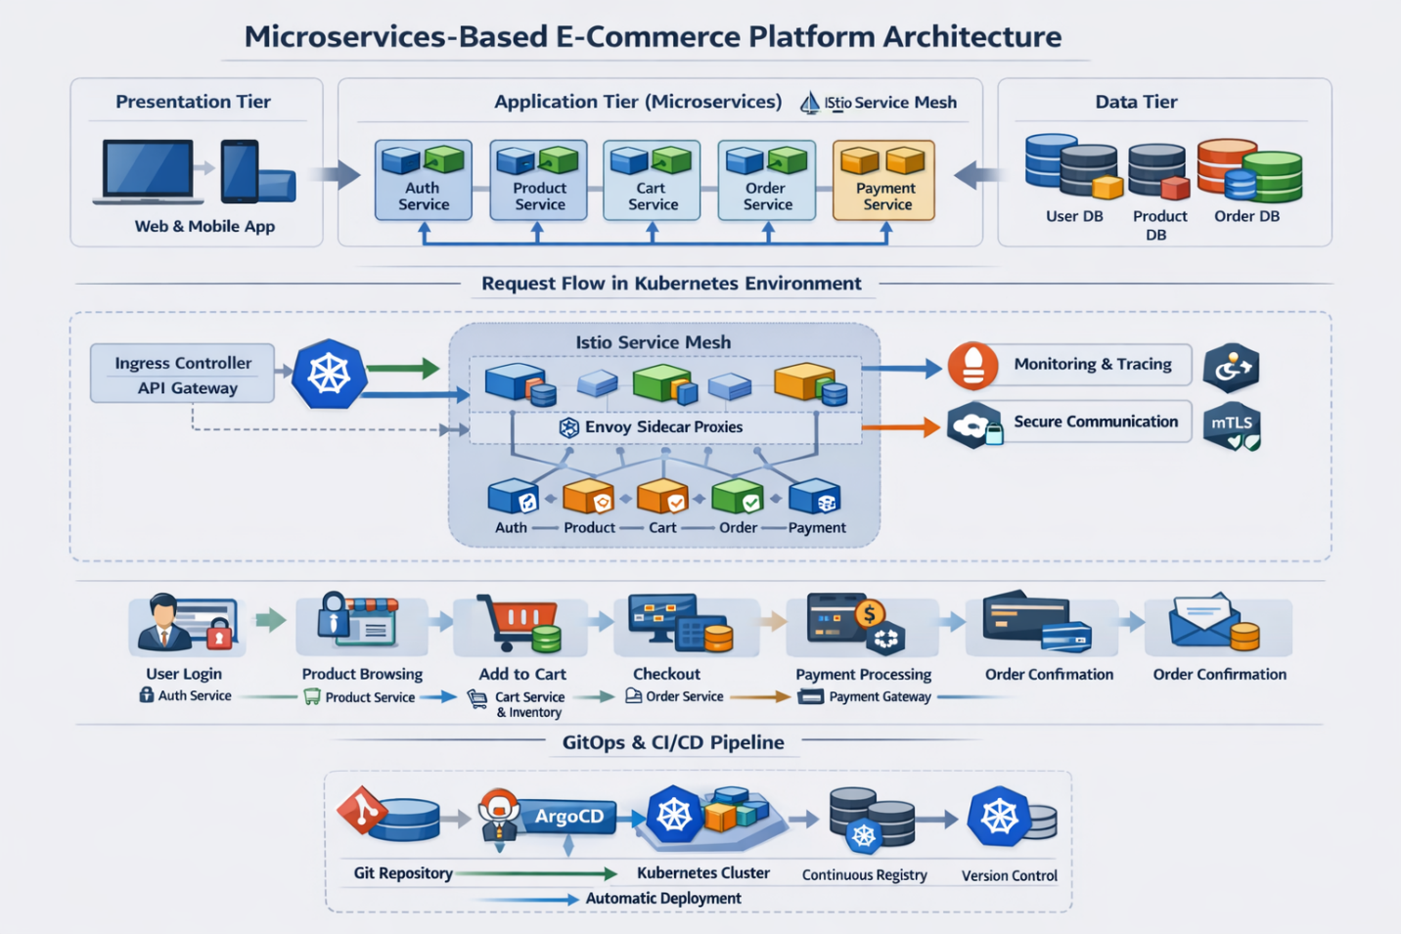

Microservices Architecture in the Application Layer
In modern e-commerce systems, the application layer is composed of multiple independent microservices. Each service focuses on a specific business capability and communicates with other services through APIs or event-driven messaging.
Typical microservices include:

- Authentication Service responsible for user login and security verification.
- Product Catalog Service responsible for retrieving product listings and product details.
- Cart Service responsible for managing user shopping carts.
- Inventory Service responsible for tracking product stock levels.
- Order Service responsible for creating and managing orders.
- Payment Service responsible for processing financial transactions.
- Notification Service responsible for sending confirmations and alerts.
- Recommendation Service responsible for generating personalized product suggestions.
Each microservice runs inside a Docker container and is deployed to Kubernetes as a pod. This modular architecture enables teams to develop, test, and deploy services independently.

Kubernetes Infrastructure Architecture
Containerization
All microservices are packaged into container images using Docker. Containerization ensures that applications run consistently across development, testing, and production environments.
Each container image includes the application code, runtime environment, system libraries, and dependencies required to run the service. These images are stored in a container registry such as Docker Hub or a private enterprise registry.
When a deployment occurs, Kubernetes retrieves the container image from the registry and runs it inside pods within the cluster.

Kubernetes Cluster Components
A Kubernetes cluster consists of a control plane and multiple worker nodes.
The control plane manages the cluster and includes components such as the API server, scheduler, and controller manager. The API server serves as the central interface through which administrators and DevOps tools interact with the cluster.

Worker nodes host application workloads. Each node runs a container runtime and a component called kubelet, which ensures that containers run correctly according to the desired configuration.
Pods are scheduled across nodes to optimize resource usage and improve reliability.

Kubernetes Networking Model
Kubernetes provides a flat networking model where every pod receives its own IP address. This allows containers within different pods to communicate directly without complex network translation.
Because pods can be created or destroyed dynamically, Kubernetes introduces Service objects to provide stable network endpoints. A service acts as an internal load balancer that distributes traffic among multiple pods running the same microservice.

External access to the cluster is handled by Ingress controllers or API gateways. These components route incoming HTTP requests to the appropriate services based on routing rules.

For example:
Requests to /products are routed to the product service.
Requests to /cart are routed to the cart service.
Requests to /orders are routed to the order service.
Internal service communication is enabled through Kubernetes DNS, allowing services to locate each other using service names rather than fixed IP addresses.

DevOps Pipeline and Continuous Delivery
Continuous Integration
DevOps practices introduce automation into the software development lifecycle.
Developers commit code to a version control system such as GitHub or GitLab. A continuous integration pipeline automatically triggers when code changes are pushed.
The CI pipeline performs several steps including compiling source code, running automated tests, performing static code analysis, and scanning for security vulnerabilities.
If all checks pass, the pipeline builds a container image and pushes it to the container registry.

Continuous Deployment
Once the container image is available, the continuous deployment pipeline updates the Kubernetes cluster.
Deployment tools such as Helm, ArgoCD, or Flux apply configuration changes to the cluster using GitOps principles. Kubernetes performs a rolling deployment, gradually replacing existing containers with the updated version without causing service interruptions.
If an issue occurs during deployment, Kubernetes can automatically roll back to a previous stable version.
This automated pipeline enables rapid feature delivery while maintaining system reliability.

Operational Scenarios in the E-Commerce Platform
Scenario 1: User Login and Authentication
When a user attempts to log in, the request originates from the presentation layer. The frontend application sends the login credentials to the backend through an HTTPS request.
The request first reaches the Kubernetes Ingress controller, which acts as the entry point for external traffic. The Ingress routes the request to the authentication service.
The authentication service validates the credentials by querying the user database in the data tier. If the credentials match the stored records, the service generates a secure authentication token such as a JSON Web Token.

The token is returned to the client application and stored locally. For all subsequent requests, the client includes the token in the request headers to verify the user’s identity.
Security mechanisms such as role-based access control and network policies ensure that only authorized services can access sensitive resources.

Scenario 2: Product Browsing and Catalog Retrieval
When users browse products, the frontend sends requests to retrieve product listings. These requests pass through the Ingress controller and are routed to the product catalog service.
The product service retrieves product information from the product database. Frequently requested data may be stored in an in-memory cache such as Redis to reduce database load.
Kubernetes services distribute incoming requests across multiple instances of the product service. This load balancing allows the system to handle high traffic volumes efficiently.
Autoscaling policies monitor CPU and memory usage and automatically increase the number of service instances when demand grows.

Scenario 3: Add-to-Cart Operation
When a customer selects a product and clicks the Add to Cart button, the frontend sends a request to the cart service.
The cart service validates the request and communicates with the product service to retrieve product information. It also interacts with the inventory service to confirm that the requested item is available in stock.
After validation, the cart service updates the user’s cart in the cart database. Many systems store cart data in Redis because it provides extremely fast read and write operations.
Once the cart is updated, the service publishes an event indicating that an item has been added to the cart. This event may be consumed by other services such as recommendation engines or analytics platforms.
Event-driven communication enables services to react to system events without creating tight dependencies between components.
Scenario 4: Checkout and Order Creation
When the user proceeds to checkout, the frontend sends a request containing cart details and shipping information.
The order service retrieves the cart contents and verifies product availability with the inventory service. The pricing service calculates taxes, shipping fees, and promotional discounts.
After validating the order details, the order service creates a new order record in the order database.
To maintain data consistency across multiple services, distributed transaction patterns such as the Saga pattern may be used.

Scenario 5: Payment Processing
Once an order is created, the payment service handles financial transactions.
The payment service communicates with external payment gateways using secure APIs. These gateways process transactions through banking networks and return a success or failure response.

If the transaction succeeds, the payment service updates the order status to indicate that payment has been completed. If the transaction fails, the system notifies the user and may allow retry attempts.
Secure communication with external services is managed using encrypted connections and secret management tools such as Kubernetes Secrets or Vault.

Scenario 6: Order Confirmation and Notification
After successful payment processing, the order service publishes an event indicating that an order has been placed.
The notification service consumes this event and sends confirmation messages to the customer through email or SMS.

The inventory service simultaneously updates stock levels to reflect the purchased items.
Finally, the frontend application displays an order confirmation page showing the order number, purchase details, and estimated delivery time.

Service Mesh (Istio) and Microservice Networking
As microservices increase in a Kubernetes-based e-commerce platform, managing service-to-service communication becomes more complex. Direct REST communication can introduce challenges in traffic management, security, observability, and fault tolerance. To address these issues, many cloud-native architectures implement a service mesh, commonly using Istio.

A service mesh introduces an infrastructure layer that manages communication between services using sidecar proxies. In an Istio architecture, each pod contains the application container and an Envoy sidecar proxy that intercepts all inbound and outbound traffic.

When a request enters the system through the Kubernetes Ingress gateway, it is routed to the target microservice. Before reaching the application container, the request passes through the Envoy proxy, where routing policies, authentication checks, encryption, and monitoring are applied. If the service needs to call another service, the request again passes through the sidecar proxy and is forwarded through the mesh to the destination service.

This architecture provides several advantages. Traffic management allows controlled routing between service versions, enabling strategies such as canary deployments. Resilience features such as retries, timeouts, and circuit breakers improve system stability. Security is strengthened through mutual TLS (mTLS) encryption between services. Additionally, the mesh improves observability by collecting telemetry data such as request latency, traffic volume, and error rates, which can be monitored using tools like Prometheus and Grafana.
By centralizing communication control, security, and monitoring, a service mesh simplifies the management of large-scale microservice systems.

GitOps and ArgoCD for Kubernetes Deployment Automation
Managing Kubernetes deployments manually can be complex and error-prone. To simplify this process, many organizations adopt GitOps, where Git repositories act as the single source of truth for infrastructure configuration.

In GitOps, Kubernetes manifests, Helm charts, and configuration files are stored in version-controlled Git repositories. Any system change is introduced through a Git commit, ensuring configurations remain version-controlled, auditable, and reproducible.

A common GitOps tool is ArgoCD, which continuously monitors the Git repository and compares it with the actual state of the Kubernetes cluster. If differences are detected, ArgoCD automatically synchronizes the cluster to match the repository configuration.

The workflow typically begins when developers push code to the source repository. A CI pipeline builds the application, runs tests, and creates a container image stored in a container registry. The deployment configuration is then updated with the new image version and committed to Git. ArgoCD detects the change and deploys the update using a rolling deployment, ensuring minimal service disruption.
GitOps also enables automatic rollback, allowing teams to revert to previous configurations if a deployment fails. Additionally, it improves security and governance through version control, approval workflows, and full configuration visibility.

By combining GitOps with Kubernetes and DevOps pipelines, organizations achieve automated deployments, consistent infrastructure management, and reliable continuous delivery.

Final Architecture Summary
In a production-level e-commerce platform, the complete architecture integrates several modern cloud-native technologies. The system follows a three-tier architecture where the presentation layer handles user interaction, the application layer implements business logic through microservices, and the data layer manages persistent storage.
Microservices are deployed in Kubernetes containers, enabling flexible scaling and independent deployments. Kubernetes networking provides service discovery, load balancing, and cluster-wide communication.
DevOps practices introduce continuous integration and continuous deployment pipelines that automate application builds, testing, and releases. GitOps workflows ensure that infrastructure configurations remain consistent and version-controlled.
Advanced infrastructure components such as service meshes provide secure and observable service-to-service communication, while monitoring and logging systems enable real-time operational visibility.
Together, these technologies create a highly scalable, resilient, and maintainable architecture capable of supporting modern large-scale e-commerce platforms.
Observability and Monitoring
In distributed microservices systems, observability is essential for maintaining system reliability.
Monitoring tools such as Prometheus collect metrics related to CPU usage, request latency, and service performance. Visualization platforms such as Grafana display these metrics through dashboards.
Centralized logging systems aggregate logs from multiple services, while distributed tracing tools track requests across the system to identify performance bottlenecks.
These tools enable DevOps teams to monitor system health and quickly diagnose operational issues.

Reliability and Scalability Features
Kubernetes ensures system reliability through several built-in mechanisms.
Horizontal Pod Autoscaling automatically adjusts the number of service instances based on resource usage or traffic levels.
Self-healing mechanisms restart failed containers or recreate pods when failures occur.
Load balancing distributes requests across multiple service instances to maintain performance during high traffic periods.
These capabilities allow the system to maintain high availability even during hardware failures or traffic spikes.

Conclusion
Combining three-tier architecture with Kubernetes-based microservices and DevOps automation enables the creation of highly scalable, resilient, and maintainable e-commerce platforms. The presentation layer handles user interactions, the application layer implements business logic through independent services, and the data layer manages persistent storage.

Operational scenarios such as authentication, product browsing, cart management, checkout processing, payment handling, and order confirmation illustrate how microservices collaborate within a Kubernetes environment. Kubernetes networking, container orchestration, and autoscaling ensure efficient communication and system reliability, while DevOps practices enable continuous integration, automated deployments, and real-time monitoring.

This architecture allows modern e-commerce platforms to support large numbers of users, process transactions efficiently, and deliver seamless online shopping experiences.

